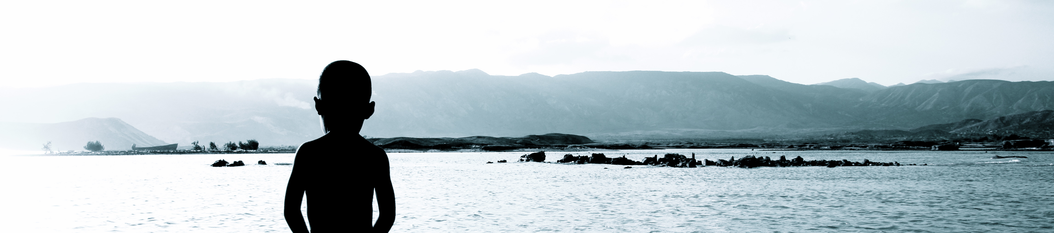
Dare To Dream

'Dare To Dream exists to see orphan care in Africa transformed as local families are empowered and the hearts of mothers and fathers are set free to love and care for the abandoned.'
Dear family and friends, Saturday, February 18, 2012
This update will be mainly about my travel to Kenya and what I will be doing there.
Class:
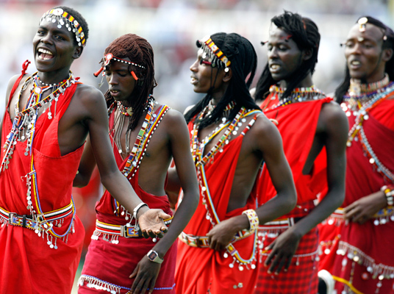
This last week has been a great week. The topic from last week was community development. I learned a lot of new things. Like what should my attitude be when entering a community, what is my goal, the process of development and much more. I also got sun burned from working to long in the sun, that was not so much fun this week.
Kenya:
This week has shown me how to start when I go to Kenya. At first I wanted to hit the ground running and ‘start’ right away. But that is not how it works. People have been telling me now multiple times that relationship is key. Now I thought, ok, relationship while I work. (Dutch mentality) No, probably the first few days I will be talking with people, just having relationship. The base director here in Costa Rica went to Kenya and he had spend the first 4 days talking with the Maasai who came walking by to get water and stopped to share stories. Also the way to enter a community is gaining the trust of the people. So my first period of time will be preparation. I will take a few weeks to observe how to people are, how their community is, who are the natural leaders in the community and talk with them building relationship and let them get to know me. During this time I will volunteer with the already existing organization; SUBA, founded by Mr. Don Richards. Mr. Don Richards has been game ranger for many years and has a lot of experience with agriculture and nature. He has started a program in Kenya called: S.E.E.K.(Suba Environmental Education of Kenya) is a grass roots organization which believes that change can only be sustainable from the bottom up as the people themselves understand their problems and initiate and implement solutions. Real abundant life comes through the gospel of Jesus Christ and the faith, hope and love He brings. Through his ministry I will gain experience, get to know the people and know where I can start my project.
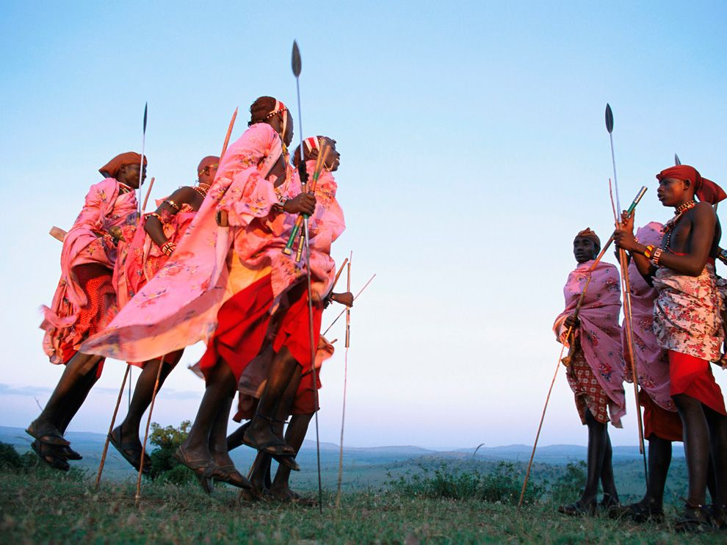
During this time I want to connect personally with orphanages, churches and other organization in that area and share my vision with them, so that I’m not doing this by myself.

What I have learned last week is to be a person in the community that most people know, trust and believe in. Through this I can be more impact full and it is easier to make a change.
Benefit Party:
Some of you have seen on facebook or actually went to this party. But for you who don’t know. Last February 10th, a group of amazing people from my hometown, Petten, had organized a party to raise money fro Dare To Dream. They had food, games, music, drinks and a lot of people who came. I wish I was there, but I couldn’t. I did make a video message which is also to be seen on my website. Like I said there were many people who have helped out. They had the supermarket Spar from Petten donate drinks, the Keet in Petten opened up their doors, Jaimey Groot and Teun Hof had organized all this. There were many more who had helped to serve thank you to: Margriet Kleef, Monica Roersma and all the people who have generously have given. Most people don’t know how much this has meant to me. It was not the money that was raised, of course it helps, but it was more having people come together because they believe in this project.
I would like to ask you to share my vision with people around you. Like my friends did was a big way of sharing, but you can share it too with your friends. The more people are behind this project the more impact we can all have. Thank you all for believing and dreaming with me.
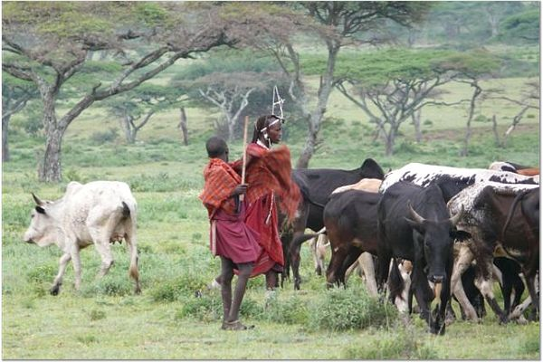
Micro finance:
As you might have already read in my previous update, I am looking into using micro financing so families can get a head start. This will be helping them to buy the right equipment selected by us so that the family has a bigger chance of succeeding. I have started to learn more about micro financing and have started to change the vision of Dare To Dream;

‘’’‘The vision of Dare to Dream is to see orphan care in Africa transformed as local families are empowered and hearts of mothers and fathers are set free to love and care for the abandoned. We will be empowering local families to be self-sustainable by educating them in agriculture, refocusing their family values based on biblical principals and placing orphans into these changed families.

Dare To Dream will be empowering the local people trough education, but also through micro loans. We will be giving small loans to local families between $50 -$150 dollars per family. With that amount we will buy the basic package
that they will need to grow their income and self-sustainability. We will provide education and work alongside them as mentors to train them and give them a better opportunity for success in providing for themselves and their family.

A major component of our training is on how to grow their produce and how to sell it for a profit and put those profits back into their farming business. The family who has taken the micro loan will be paying the amount back within 12-18 months (depending on what the loan is used for and the amount of the loan), with a 11% interest over the total amount.’’’’
I’m looking for people who want to support not only me, but the micro loan project. If you would like to sponsor me, please send me an email. Or write with your donation; support micro finance.
This is what has been changing since the last time I wrote you. Thank you all for your support, know that I couldn’t do this without your support. Thank you all!
Love and Blessings,
Bob de Groot Dare To Dream Web: www.projectdaretodream.com Email: projectdaretodream@me.com

Dare To Dream

'Dare To Dream exists to see orphan care in Africa transformed as local families are empowered and the hearts of mothers and fathers are set free to love and care for the abandoned.'

