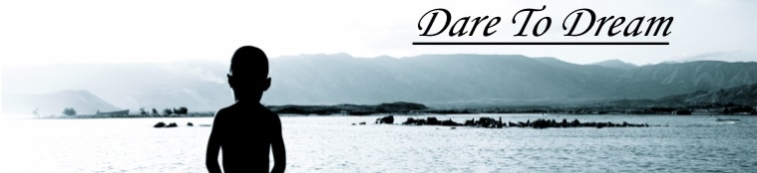

Dear friends and family,

I'm happy to say that I have made it to Mbita, Kenya. After spending the night in London and in Nairobi, then taking a bus to Homa Bay. Then taking a taxi that got stuck in the mud, so we had to walk 5km in the rain and mud, in the dark. But I made it safely.

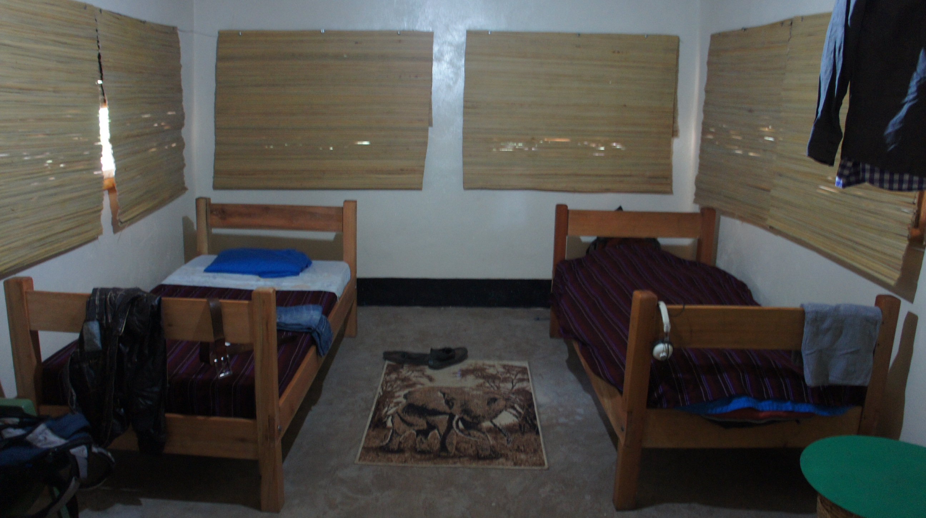
I have a little hut on the base right at the lake, during the night I hear the hippos and the monkeys. The base is in the middle of the bush, so I always have to watch out for snakes and other dangerous animals. The morning after I arrived, I unpacked and got settled. Then I went over to the director’s house, Don Richards to have coffee and some breakfast. We talked for a while before we went to look at the base and show me around. They want to keep the base as wild as possible, meaning leaving a lot of plants, trees and animals. There are 2 gardens here with fruits and vegetables. There are also goats and chickens.
The people here are amazing, they laugh all the time and make me feel very welcome. I met a lot of people and feel sorry that they know my name, but I can't always remember their names.

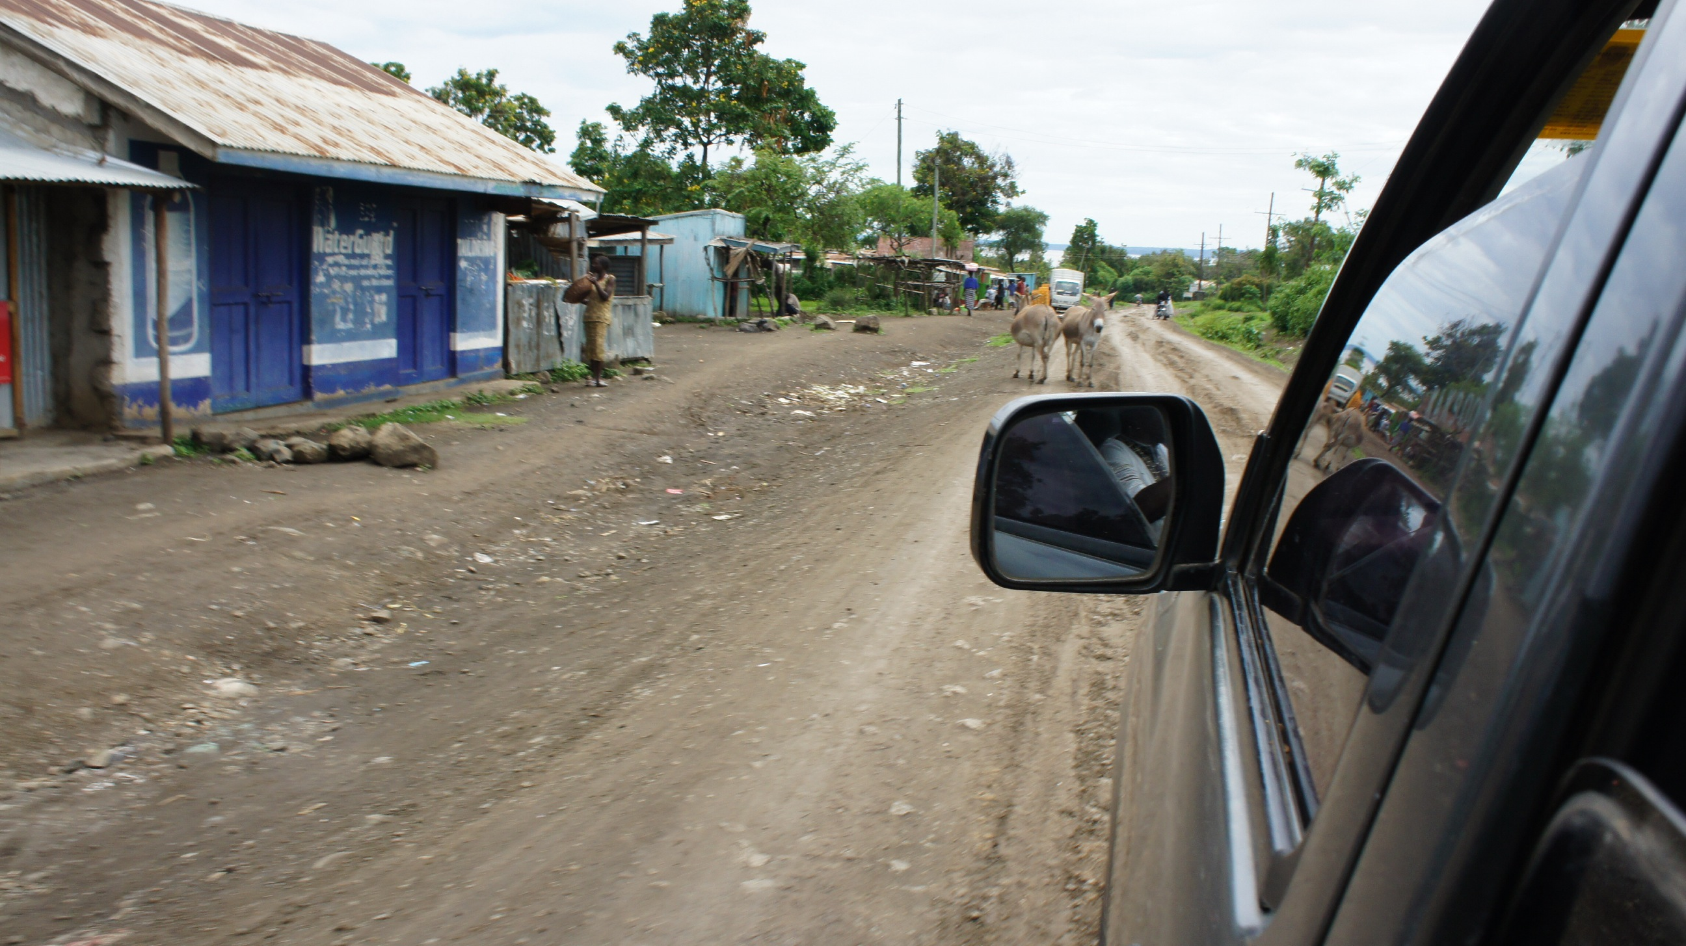
It is still really unreal the fact that I'm in Kenya, Africa. After waiting for this for 6 years I'm finally here. I don't know if it hit me already. I keep telling myself, 'Dude, you're in Kenya, you are in Africa.' This will probably take a while before it sinks. All I know is that I'm loving it here and looking forward getting in routine here.

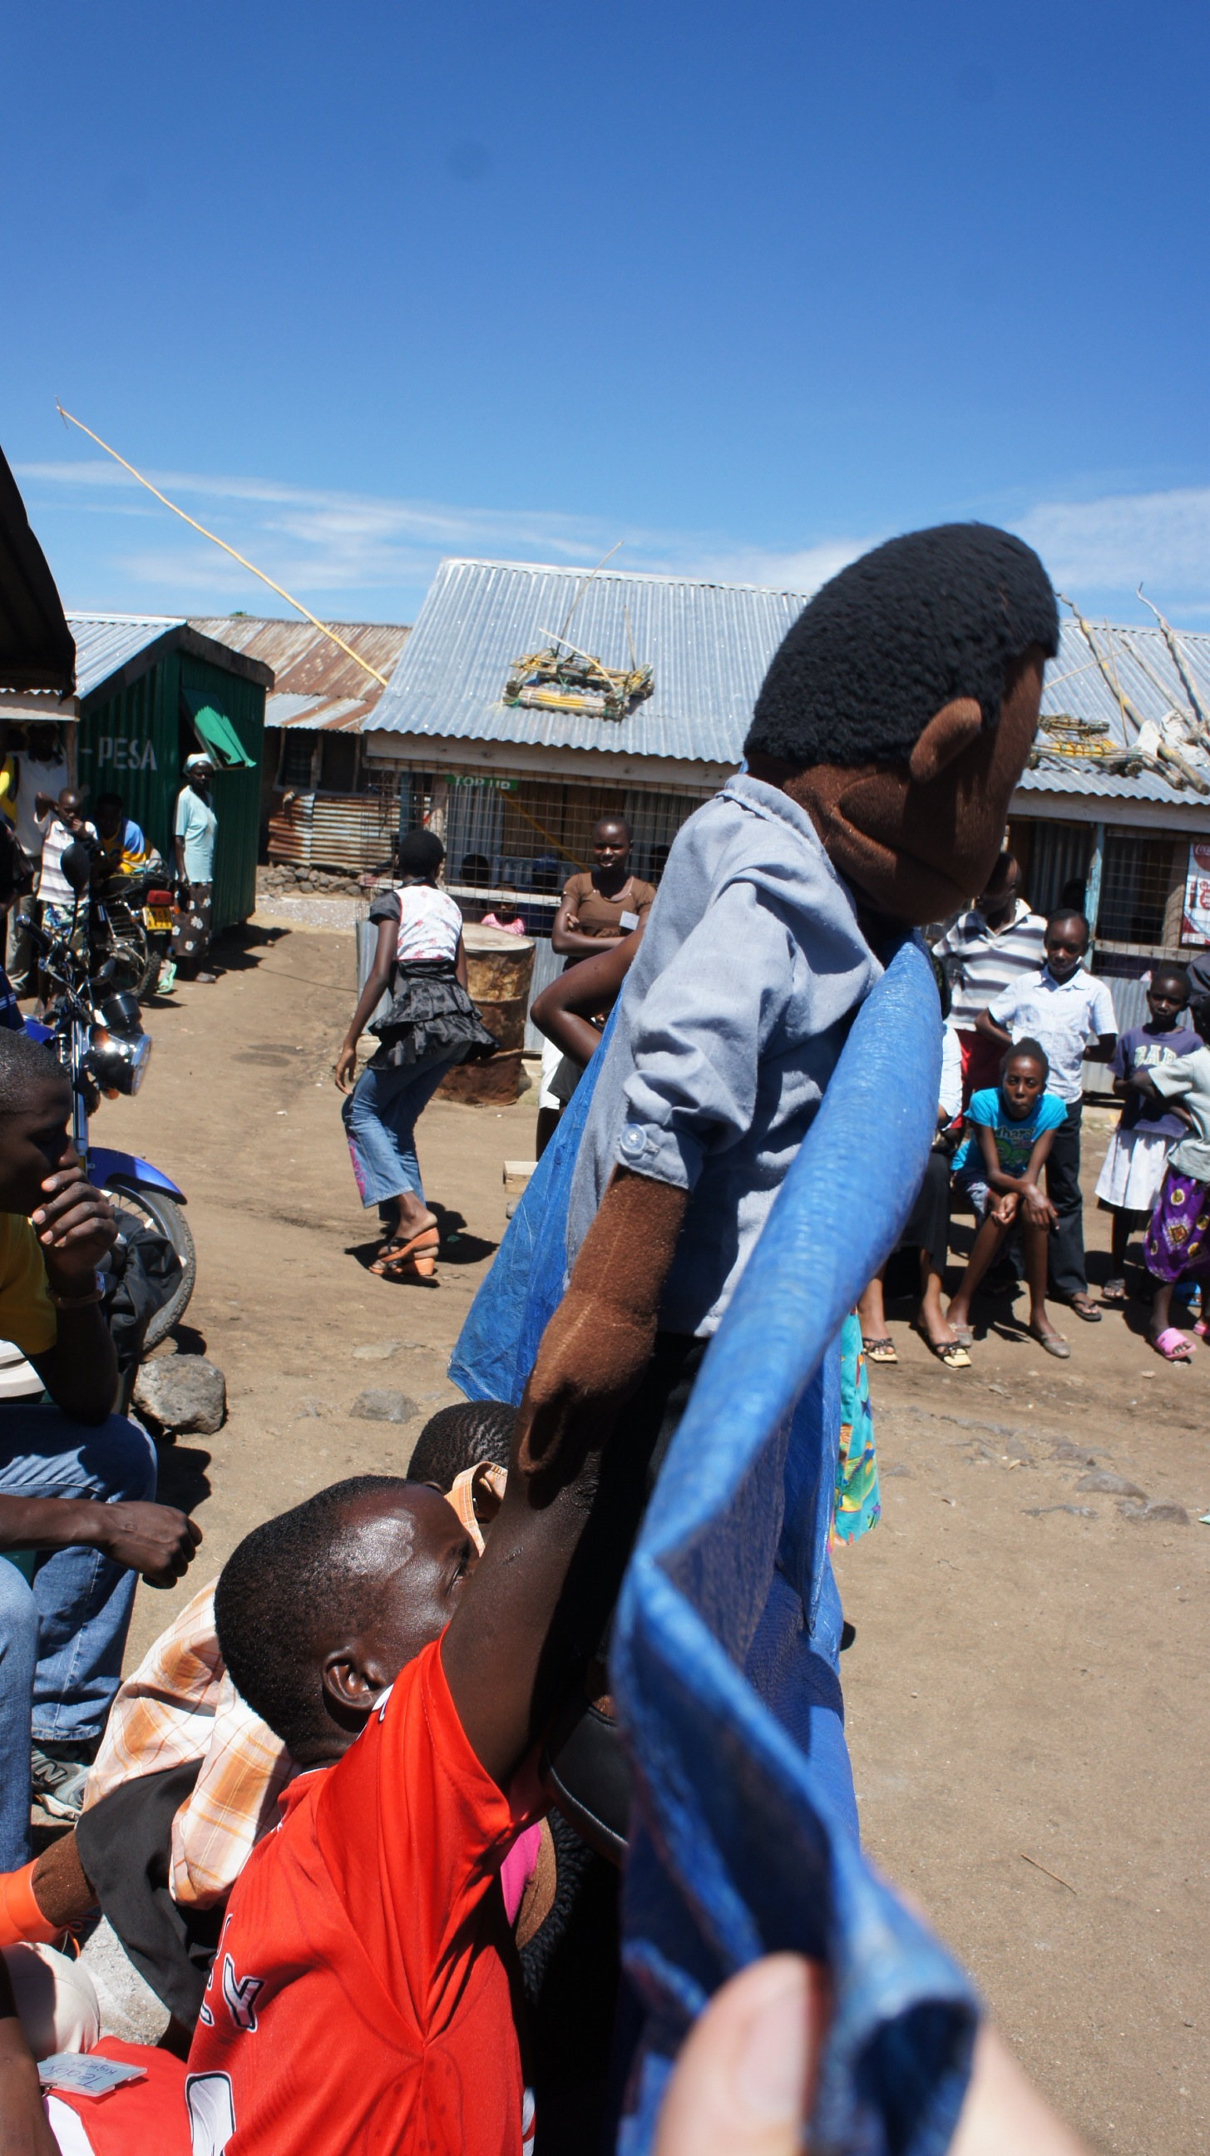
Friday the 4th we went to a fisher village not to far from the base. We have started a water program there that provides safe water for the people. Because of this diarrhea, typhoid and cholera has reduced.
We had to go to the village because someone stole the solar panels that powered the system. This was my first meeting with the village committee, and it was very interesting to hear and see what happened. We also spoke with the police and found out that they wanted a bribe.
This is something that happens a lot in these villages. Also there is a lot of impurity like adultery, (child)-prostitution, stealing lying and a lot more. We are trying to teach them more and more what and how to change their lives. Hopefully soon I can bring you good news on how things have changed here.

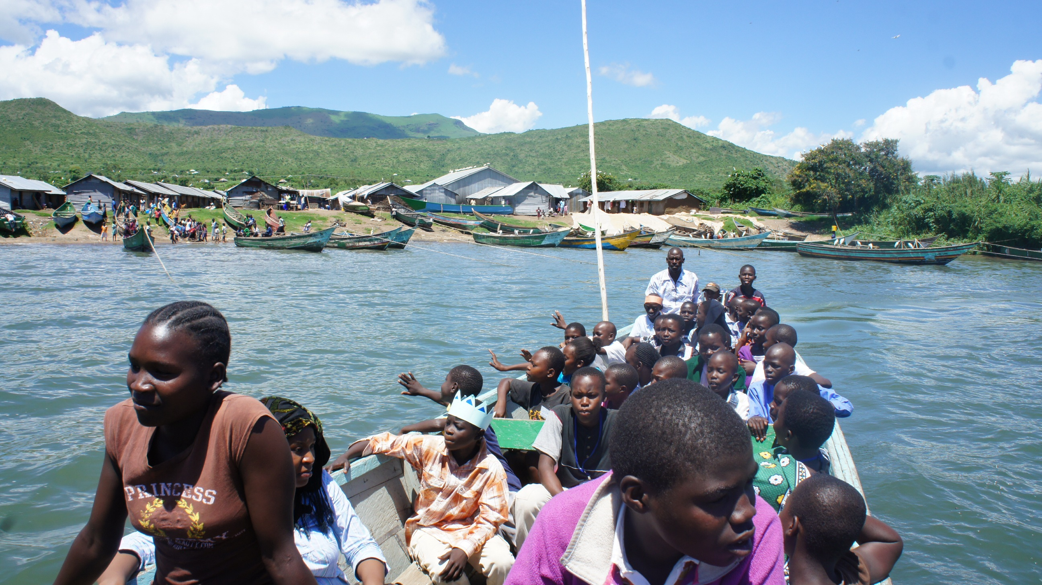
I have also met with a micro finance officer here in Mbita to talk about how they do their small loans and all. Our base has been in contact with a lot of widows and were talking about how they are suffering. When I heard that the thought came up to start with micro finance with them. Teaching them certain trades and them lending them the money to get them started. Thats why I met with one of the banks here in Mbita to ask and see how they go through the whole process. I learned a lot from that meeting and gave me a good view on how it is in the field. Now I'm going to put everything down on paper and put all the steps in here. I already had a lot, but now I need to translate it into this situation. I'm looking forward to doing this and getting to work on this. Especially because the widows are such a big part of the community here and these woman take care of a lot of orphans.

When I wrote the part above this I didn’t meet with anyone here on the base. Now I have and we will start this coming Monday on giving 5 widows a garden to first provide for them self’s and run this as a trail. The next step is then to give them a loan so that they can have a profit. Please be praying for this and thank you all who have been giving to Dare To Dream. Starting Monday 5 widows and their children will be able to provide food for them self’s.

Needs/prayer points:

- Favor here among the people.
- Creativity and ideas for running the micro business for widows
- That my body gets used to the climate. (Right now the sun drains me)
- I’m looking for people to join me here in Kenya.
- I’m still looking for financial supporters, preferably on a monthly base.
- Encouragements by email, letter or any other way

Love&Blessings,

Bob de Groot
www.projectdaretodream.com

